**Assignment 2.4**

**Becca Buechle**

**Personal Portfolio (Milestone 2): Prototype Submission**

Using the knowledge gained in last week’s market research assignment, design a prototype/sketch of the portfolio's layout and intended functionality.

**Deliverable:**

* Prototype/sketches
* Images, if any
* Link to your GitHub repository – hint: use the repository created in WEB 201, username.github.io

**GitHub Link:**

https://github.com/rbuechle/rbuechle.github.io

(I think this is the correct link)

**Prototype:**

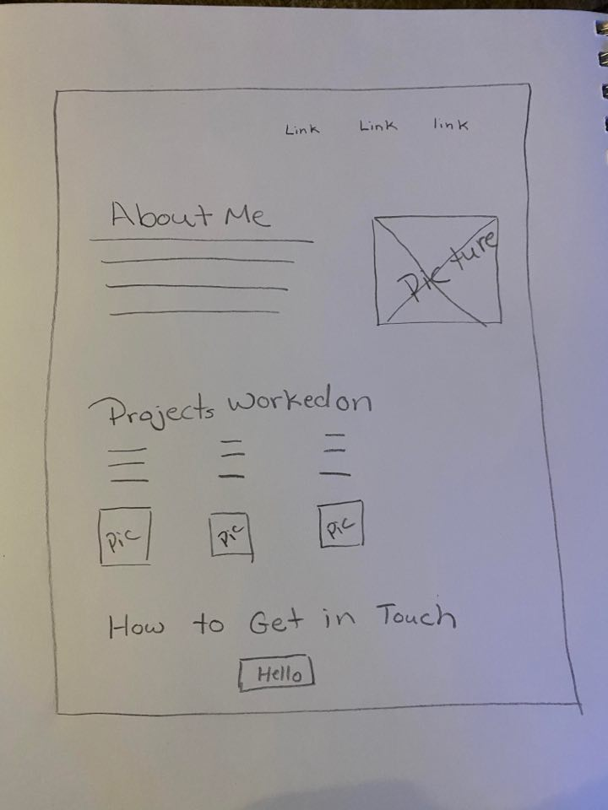

**Intended functionality:**

This site will be fairly simple it will have links across the top that link to other places in the page such as contact me and my bio. I’d also like to include some information about projects that I have worked on during my time in school that I am proud to showcase as well as just a little tidbit about what the project was. I’ll also have an area that tells about my skills such as which coding languages I know and such. I think I would like to maybe add a place to showcase my resume and also a way to have them contact me at. I’m still trying to decide if I want to have any kind of pictures for the background or keep it simple with some blues (favorite color).